目录

1. Web3 Integration 2

1.1 2 ways to interact with blockchain 2

1.2 query data 4

1.3 add web3 to the frontend 4

1.4 add IPFS 6

2 Write a Store Factory (no Proxy) 6

1coding 7

Step 1 start ganache 7

2 Manual test 8

3 make privateStamp factory upgradeable 8

3.1Verify old logic 8

3.2 Upgrade to v2 9

# Web3 Integration

## 1.1 2 ways to interact with blockchain

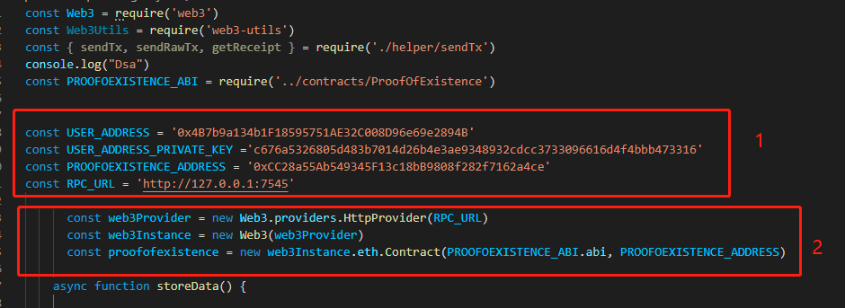

Step1 : set addresses

Step2: create web3 connector

1 web3 send transaction

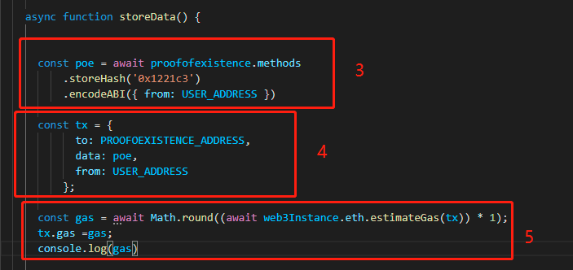

Step3:get method encode

Step4:assign encode and other params to tx

Step5:get estimate gas

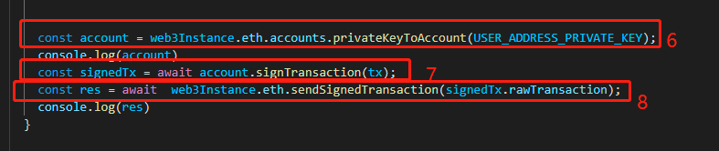

Step6:import web3 eth account from private key

Step7:sign the raw data with pk

Step8: send signed transaction to blockchain

2 RPC post request

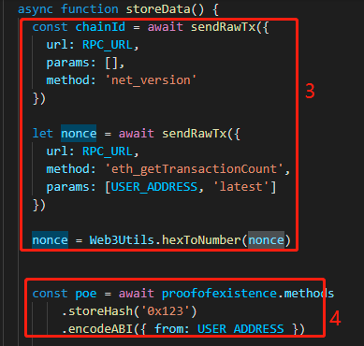

Step3: get chainid and nonce

Step4:get methods encode

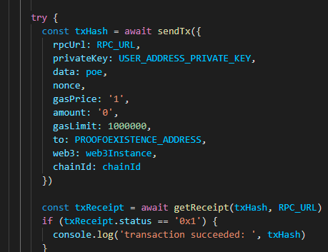

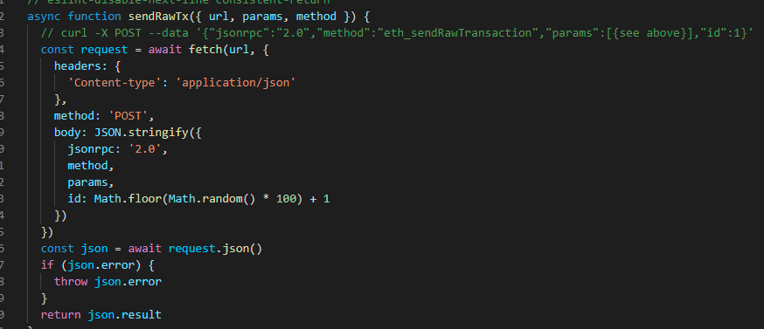

Use rpc post api to send signed raw data

## 1.2 query data

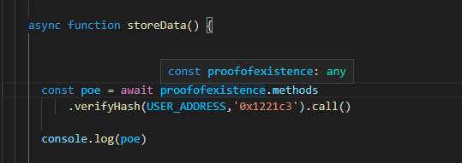

Use .call()

## 1.3 add web3 to the frontend

Step 1: convert the script to class

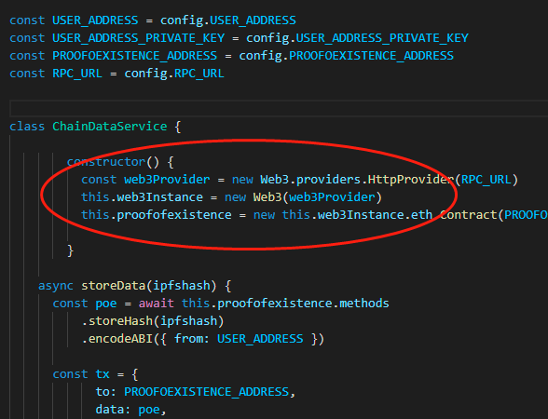

Make web3connector part to be the constructor

And put the rest of the code from the scripts to the storeData function

Step2: add input button to the front end

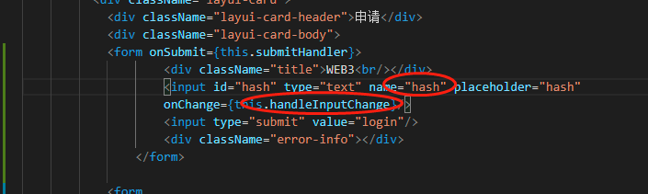

Step3: add event handlers

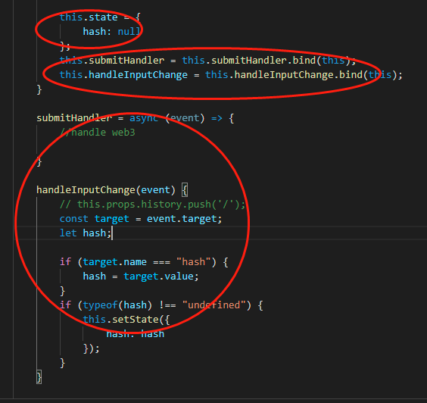

Set state

Set event handler

Bind this

Step 4: add submit and web3 interaction

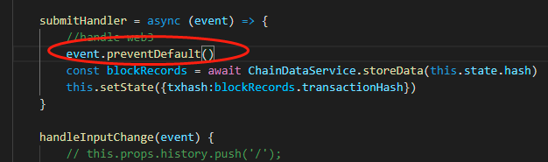

## 1.4 add IPFS

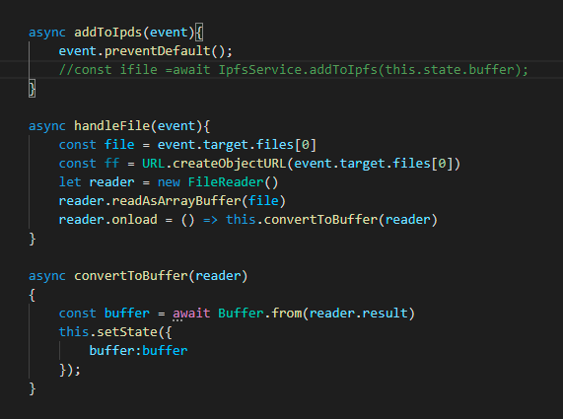

Store files in buffer state variable

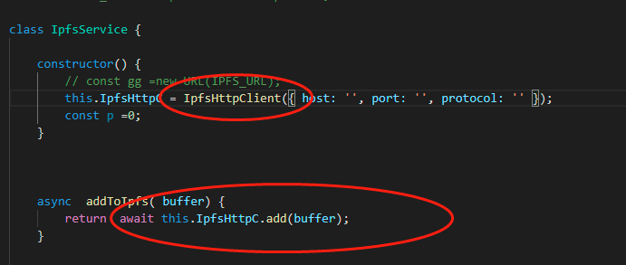

Upload buffer to ipfs-client

# 2 Write a Store Factory (no Proxy)

Github.com/onebit256/proxy

## 1coding

## Step 1 start ganache

Ganache-cli -m ‘’

Truffle init

Npm init

Npm i @openzeppelin/upgrades@2.8.0

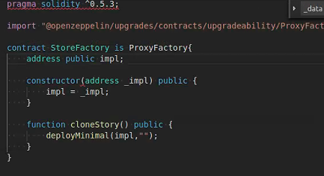

As there is no init function

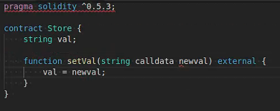

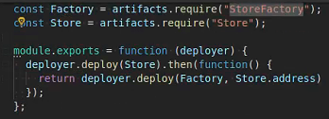

If there are init data

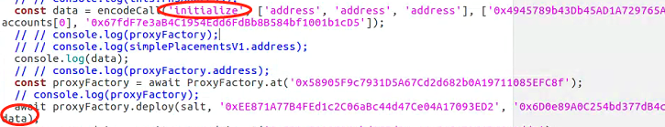

## 2 Manual test

Const sf = await StoreFactory.deployed()

Sf.impl()

Networks

Sf.clonestore()

Sf.getPastEvents()

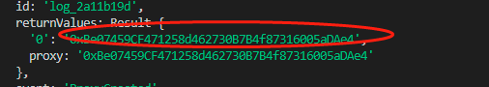

Const St1 = await Store.at(‘0xBe07459CF471258d462730B7B4f87316005aDAe4’)

St1.setVal(“ss”)

St1.val()

Sf.clonestore()

Sf.getPastEvents()

Const St2 = await Store.at(‘0xBe07459CF471258d462730B7B4f87316005aDAe4’)

St2.setVal(“ss”)

St2.val()

Sf.clonestore()

# 3 make privateStamp factory upgradeable

## 3.1Verify old logic

const proxyFactory =await ProxyFactory.at(ProxyFactory.address)

const proxyAdmin =await ProxyAdmin.at(ProxyAdmin.address)

const salt = "20";

const deploymentProxyAddress = await proxyFactory.getDeploymentAddress(salt, accounts[0]);

const implementationAddress = await proxyAdmin.getProxyImplementation(deploymentProxyAddress);

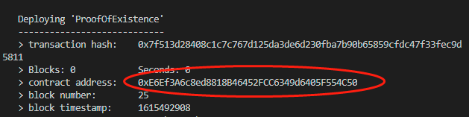



const poe1 =await ProofOfExistence.at(deploymentProxyAddress)

poe1.storeHash("123")

poe1.verifyHash(accounts[0],"123")



## 3.2 Upgrade to v2

await proxyAdmin.upgrade(deploymentProxyAddress, ProofOfExistenceV2.address)



const poe2 = await ProofOfExistenceV2.at(deploymentProxyAddress)

